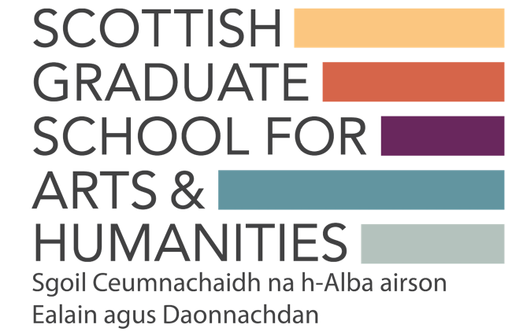

Discipline+ Catalyst
Event Advertising Template
Once Catalyst Training Plans have been approved and the date(s) for events confirmed this template should be completed and returned to SGSAH. We then use these details to advertise training events through our website and social media channels. Alongside this we also recommend utilising the networks of Catalyst members and your HEIs to circulate event information.
Please note, it is the responsibility of the event organiser, Catalyst Lead/Deputy or relevant HEI admin support (for Catalyst Lead) to ensure the booking information is set up in advance of the event being advertised (through Eventbrite for example).
Please complete this form and submit it to mariam.jack@sgsah.ac.uk at least one month prior to the event. This will allow us to promote all events via our communication channels.

Discipline+ Catalyst:

Event Name:

Event Date:

Event Online Platform/Physical Venue:

Event Registration Deadline (to be made public with advert):

Any participant requiring BSL should notify the organisers by this date.

Booking/Eventbrite Link:

*When circulating the booking/Eventbrite please request that participants use their HEI email addresses to ensure those signing-up are from Scottish HEIs

Event Contact Email (to be made public with advert – usually event organiser):

Event Summary:
Please provide a c.200-word summary of your event suitable to be used as an advertisement on the SGSAH website (can be copied from original Catalyst Training Plan).

