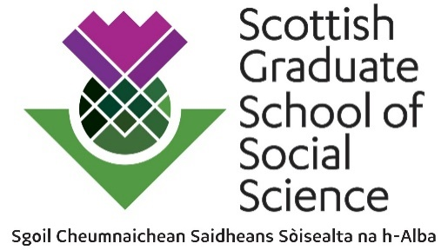

Application for Funding: Spring into Methods 2022/23

Workshop Proposal
Please read the guidance notes before completing this form.
Please submit your application form via Social by 3pm on Friday 03 February 2023.

Event Title

Lead institution hosting the event

Lead organiser contact details
Name/email/telephone
Other contributors
Name/Position

Proposed dates of event
Must span no more than 15 hours between 10 April and 26 May 20223, avoiding Easter
Format
Online/In Person/Hybrid
Technology
Any online or hybrid sessions will be delivered using the organiser’s preferred technology. A summary should be provided here. A group will be set up on Social for pre-event discussion, sharing of materials, posting announcements, post-event follow-up etc. Please note any specific requirements here.
Maximum number of attendees
Name(s) and role(s) of ECR(s)

Details of the event
600 words max
Please provide an outline of the Spring into Methods training event, to include:
- Aims, objectives and learning outcomes
- Details of the personnel involved
- Format
- Any prior learning required
- Other relevant information (e.g. provision of equipment or learning materials, how you will ensure the event is fully accessible etc.)

How will this event be relevant to students across and beyond arts, humanities and social science disciplines?
200 words max
Please outline the role of any external partners in delivery of the event (optional)
200 words max
Please outline any resources that will be made available for SGSAH and SGSSS online learning provision post-event
200 words max
Please provide promotional text that we can use to advertise your event to students
400 words max

Costs
Please provide a breakdown of the costs of your proposed event. It is important that you supply sufficient information to enable value for money of your application to be assessed. This includes any materials as well as flat-rate payment for fixed-term early career researchers (ECRs) or doctoral researchers, being clear about the duties to be included. Please also include in-kind costs.
The total claim should not exceed £2,500. Please refer to the guidance for further details.
Item/Activity | Cost
Total

