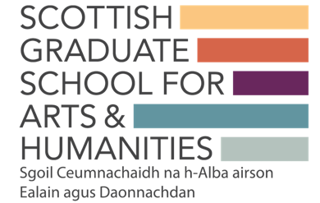
KE Hub Event Advertising

Please complete one of these forms for each of your events and send to Helen.Kendrick@sgsah.ac.uk at least 8 weeks prior to the event. This will allow us to promote all events via our communication channels.
We’d ask you to also circulate event information through your own networks and through your HEIs.

Please note, it is the responsibility of the event organiser, Hub Lead/Deputy or relevant HEI admin support (for Hub Lead) to ensure the booking information is set up in advance (through Eventbrite for example).

Name of KE Hub:

Event Name:

Event Date.& times:

Event Online Platform/Physical Venue:

Event Registration Deadline (to be made public with advert):

Any participant requiring BSL should notify the organisers by this date.

Booking/Eventbrite Link:

*When circulating the booking/Eventbrite please request that participants use their HEI email addresses to ensure those signing-up are from Scottish HEIs

Event Contact Email (to be made public with advert – usually event organiser):

Event Summary:
Please provide a c.100-200 word summary of your event suitable to be used as an advertisement on the SGSAH website (can be copied from original Hub Training Plan).

